About the Participants  FGDM participants are anyone you believe is committed to helping establish a support plan. Families let the facilitator know who they have chosen to invite. Fortunately, the definition of “family” is evolving in this country. This may include a blood relative, a step relationship, extended family member or a close friend who feels “like part of the family”. It will also include resourceful persons and professionals from the community (clergy, teachers, close friends, social workers, probation officers, therapists, and directors of intervention).  People gather to focus on what is in the best interest of the children.  What is in a plan?  How will a safe, stable, and permanent home be provided for the child?  What does the child need to be safe?  What is needed to promote and build on the unique strengths of this family?  How will we best support superior functioning in this family? |  | Preparation for the FGDM Meeting  A neutral, third-party facilitator will discuss the FGDM meeting with you. The family makes a list of people they would like to invite to the meeting. The facilitator will invite all participants and make all arrangements including an appropriate and convenient time and place for everyone to meet.  The decision-making meeting  Everyone will be given time to meet each other. Information will be discussed regarding the family’s strengths, goals, needs, and concerns.  Once all the information is brought to the table, the family is given time to discuss and determine their preferred choices for safe and nurturing living arrangements for the children involved.  The team and family will reconvene to discuss the family’s plan, answer any questions, and make suggestions. Compromises are made to secure safe and legal resolutions.  Greater Minnesota Family Services  Phone: 320-214-9692  www.greaterminnesota.org |  | Family Group Decision Making  - Funded by: Department of Human Services  FGDM Coordinator  Denise Rude  (507) 613-8025

R
What is Family Group Decision Making?  - Family Group Decision Making is a facilitated, confidential meeting between family, friends, and professionals.  - It empowers support systems to work together for the purpose of providing a safe, secure environment, free from abuse and neglect for the child/children. |  | 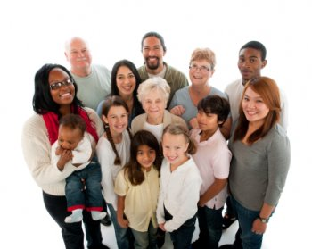  Bringing it to the table…  Families want what is best for their children, but sometimes life throws some serious challenges our direction.  When a child’s safety or well-being is in jeopardy, a family may need to decide how to keep their children safe while continuing to provide support as they grow. |  | Is FGDM right for my family?  A FGDM meeting would be helpful if:  - If your child is in foster care or lives in another setting away from home.  - The Human Service agency determines that child protective services are needed.  - You and your family and friends are willing to share ideas, discuss creative solutions and work toward a thoughtful agreement.  - A parent or legal guardian of the child is able to enter into an agreement.  - If you have concerns that your child is unsafe in his or her home.

