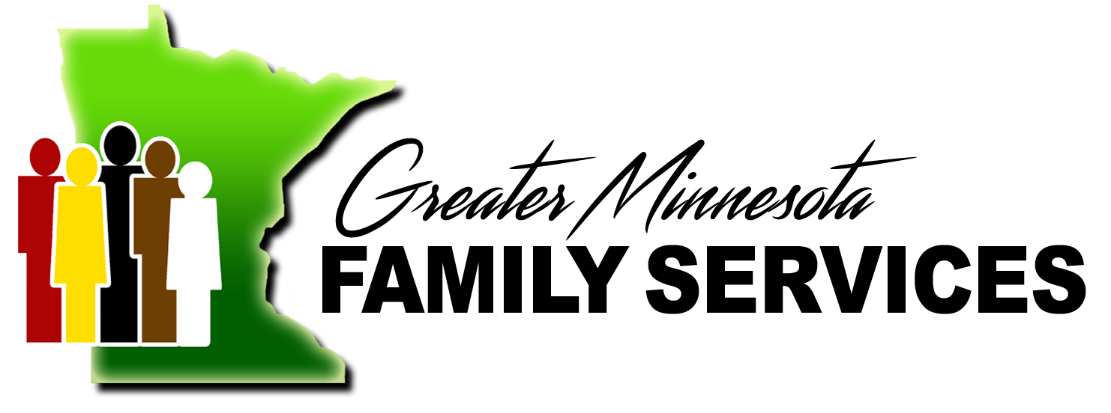

2320 Hwy 12 E ● Suite 2 ● Willmar, MN 56201; Ph: 320-214-9692 ● Fax: 320-214-9924

"GM GIVES AND PAY IT FORWARD"

GM GIVES AND PAY IT FORWARD
I authorize GMFS to use donations and funds at GMFS discretion, knowing that 100% of my donation will go to clients for GM Gives and current employees for Pay It Forward. DONATIONS ARE NON-REFUNDABLE

Contribution Information (Please indicate your contribution amount and frequency):
$ | - Per Pay Period of my compensation before-tax contributions to GM GIVES fund until such time as I revoke or amend my election.  - Per Pay Period of my compensation post-tax contributions to the PAY IT FORWARD fund until such time as I revok or amend my election.  - One time gift of .
Please make my ongoing contribution effective (date of first contribution).
I authorize Greater Minnesota Family Services to process according to the contribution information above. I understand and agree to the terms of this Agreement. I understand that this authorization will remain in effect until I provide reasonable notification of its termination or choose to amend my election amount.

Participant’s Name: .

Participant Signature: Date: .

